**Course: IC3234– Building and Process Automation Lab- 4**

**Class: T.Y.C. B. Tech (Instrumentation and Control Engineering)**

**Academic year 2021 – 22**

**Name: Shaunak Deshpande**

**Div.: TY-IC-C**

**Roll. No.: 39**

**GR no.: 11911180**

**Batch.: 2**

### LAB 4: Feed forward Control scheme for Steam heater Temperature control

### Title:

The process example for this Lab Experiment is a heater. The heater outlet temperature is controlled by manipulating the steam input to the heater. The temperature of the liquid feed to the heater is measured and is available to the control system as a disturbance input.

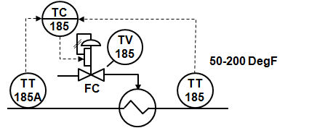

**Task-1:** To observe the response of feedback control for the steam heater application.

Step-1: In the workspace, set the mode of the PID to Manual using the MODE parameter.

Step-2: Disable Feed-forward control by putting FF-Enable : False

Step-3: Introduce an unmeasured process disturbance by changing the DISTURBANCE input. e.g. 10 to 20 %

Step-4:Observe the impact on the process and the action taken by the PID block to return the temperature to its setpoint. Measure the response time.

**Workspace**

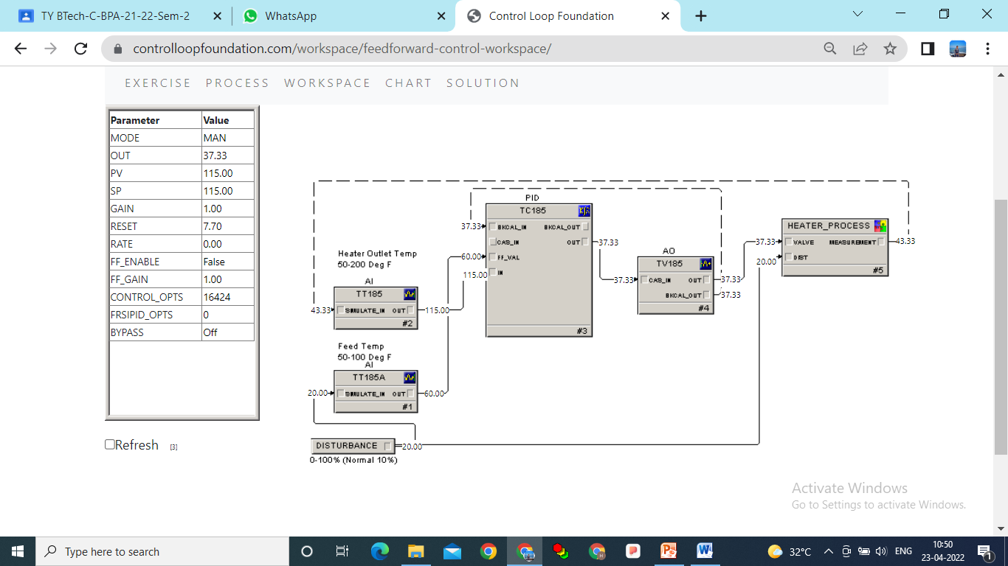

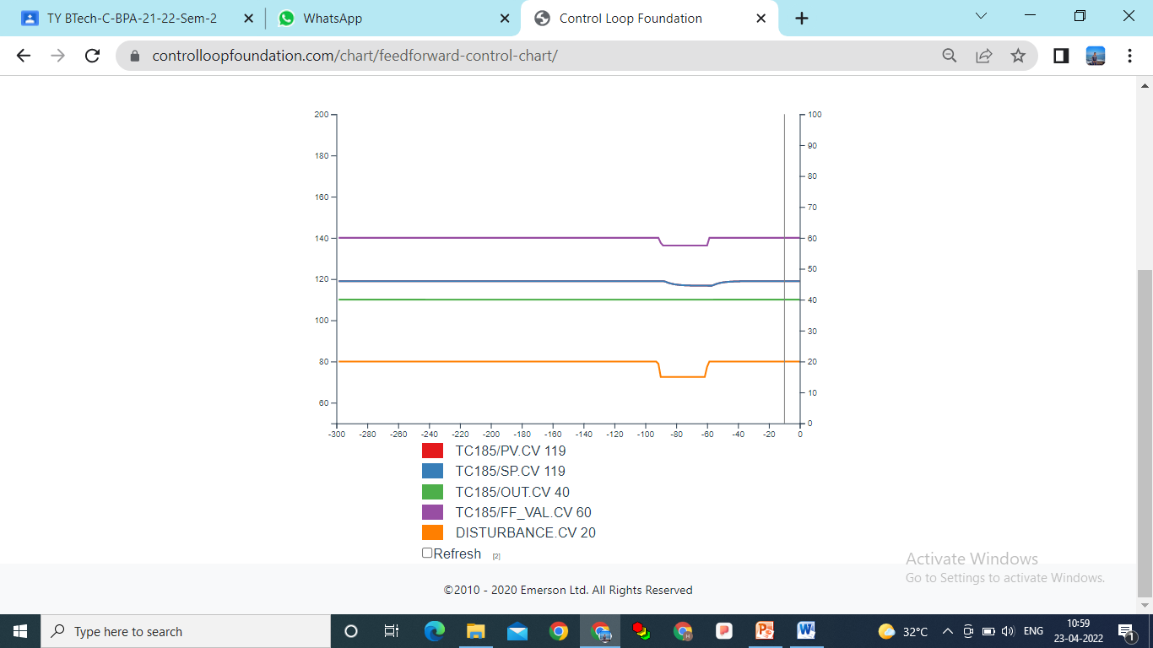

**Task-2 To see the effect of Feed-forward control scheme**

1. **Find the process gain due to change in manipulated variable**

Step-1. In the workspace, set the mode of the PID to Manual using the MODE parameter.

Step-2. Change the PID output using the OUT parameter and observer the process response.

(e.g. – 50 % to 60%). This is step change of 10% in the manipulated variable.

Step-3. Determine the process gain, dead time (DT1) and time constant for this step change.

(e.g. – process gain = 1)

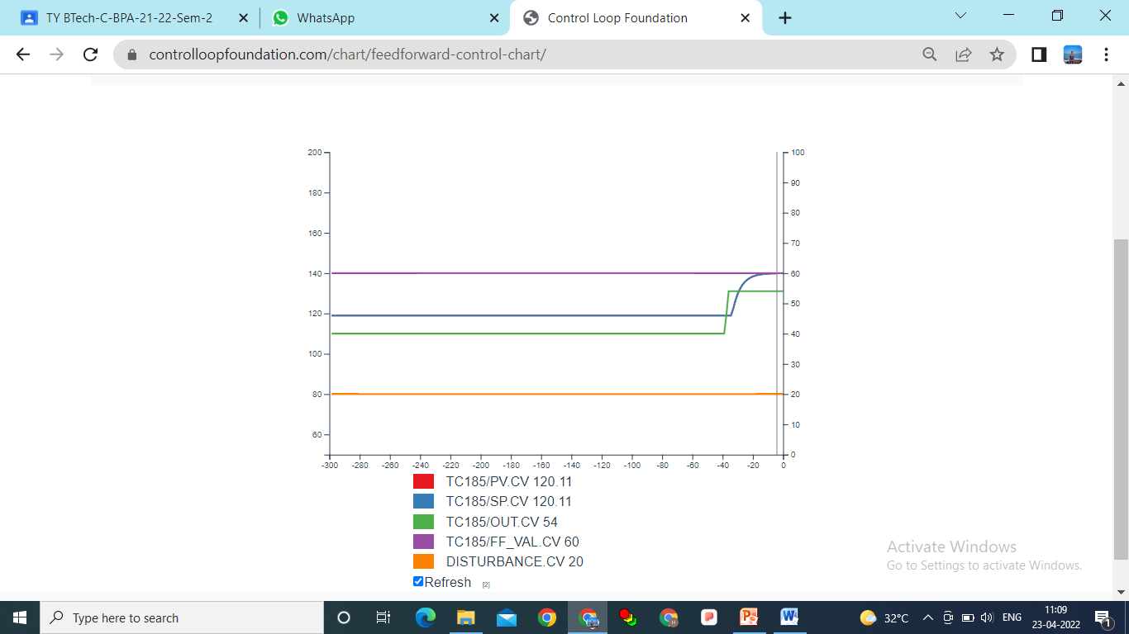

**Task-2**

1. Find the process gain due to change in the process load (disturbance)

Step-1. In the workspace, set the mode of the PID to Manual using the MODE parameter and allow process to reach at the steady-state.

Step-2. Introduce an unmeasured process disturbance by changing the DISTURBANCE input. e.g. 20 % to 30 %

Step-3. Observe the impact on the process and the action taken by the PID block to return the temperature to its setpoint

Step-4. Determine the process gain, dead time (DT2) and time constant for this disturbance change. (e.g. – process gain = 0.3)

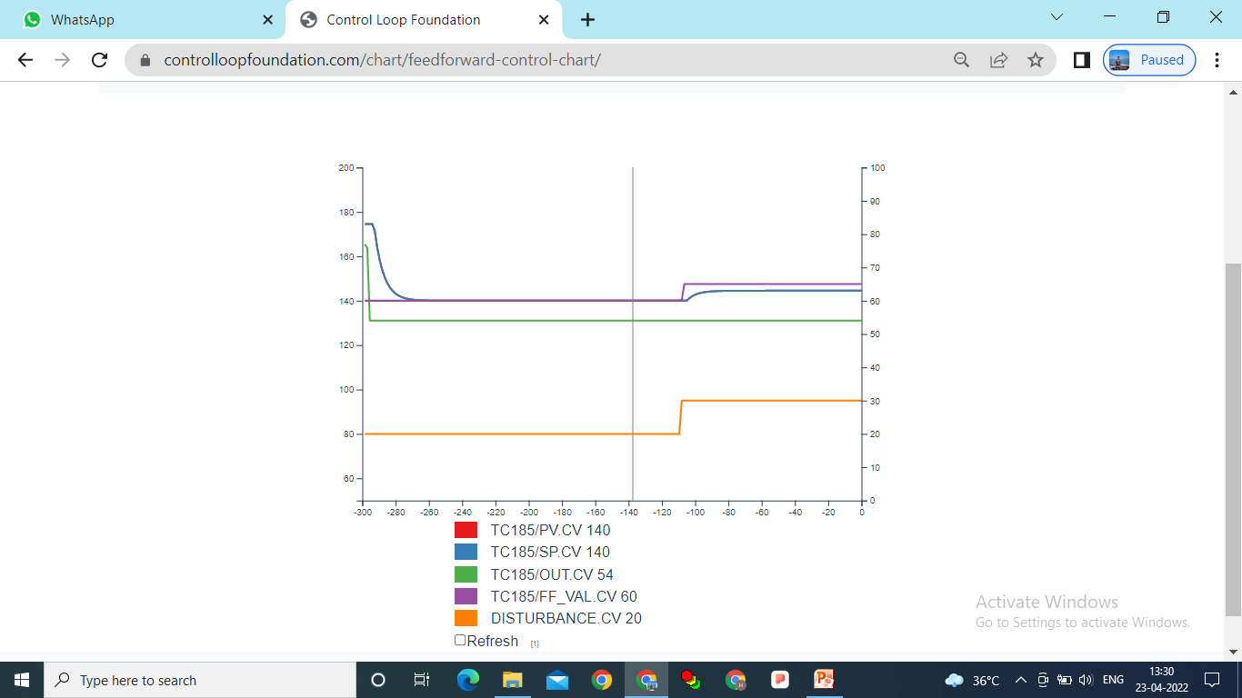

Step-5: Determine the FF_Gain that will compensate for the disturbance.

FF_Gain = - ( Gain_Disturbance input / Gain_Manipulated variable input)

= - (0.3 / 1) = -0.3

Step-6: Enter this FF_Gain value to the PID controller.

Set the mode of the PID to Manual using the MODE parameter and enable Feed-forward control by putting FF-Enable : ‘True’

Step-7. Put PID controller in AUTO mode using Mode parameter

Step-8. Introduce an unmeasured process disturbance by changing the DISTURBANCE input. e.g. 30 % to 40 %

Step 9. Observer the process response and the action taken by the Feedforward controller to minimize the impact of the disturbance.

You will get rapid change in the output. Response is much faster.

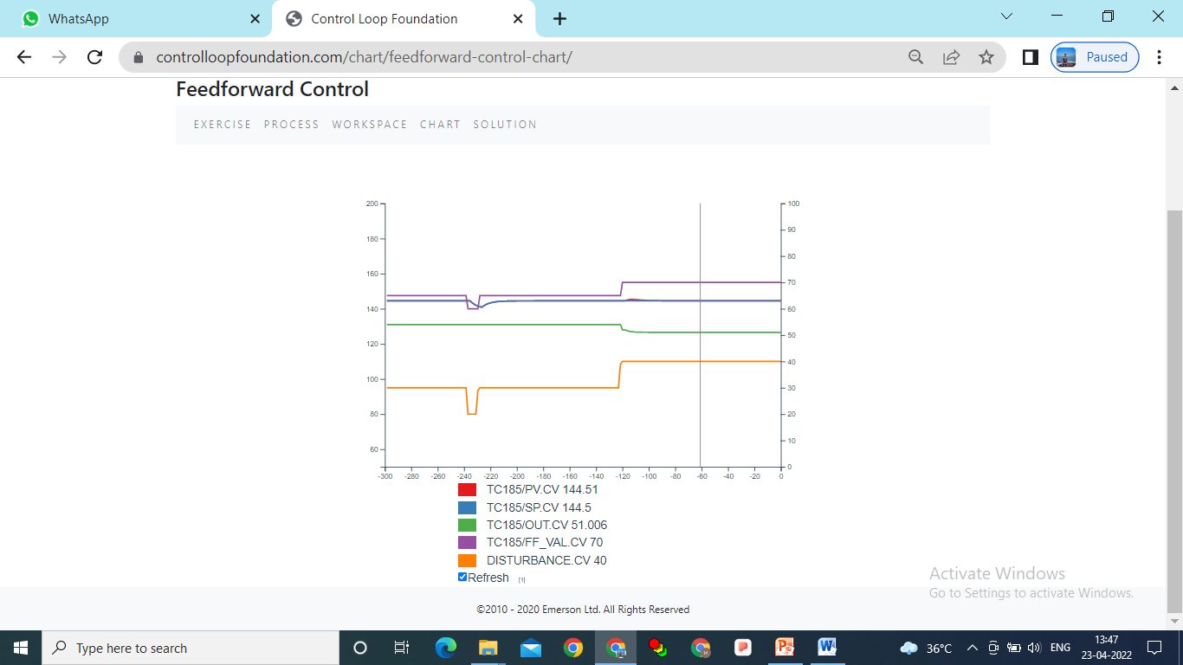

### Conclusion: In tis lab we study and understand about Feed forward Control scheme for Steam heater Temperature control.

Also we know how feed-forward control may be used for the steam water heater to correct for the changes in the feed-water temperature before they impact the outlet water temperature.